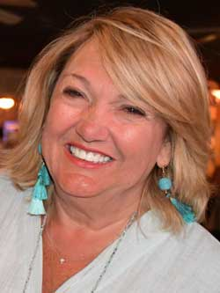

Candy Long

To the ACSC Nomination Committee:

My name is Candy Long and I am respectively submitting my name as a candidate for the Vice Chair position of the ACSC Board. I have been a proud member of Rock Hill Shag Club since 2006 and have served on it’s Board in different positions. As Social Director in 2020 and 2021, we had the task of navigating our club through Covid as well as the loss of our meeting venue. Thankfully our club is still strong and thriving.
I have also chaired each of our annual “Vegas Night” fundraising events. We are thrilled to have donated close to $80,000 to The Hall of Fame Foundation!

Offices Held & Term:
2008 Secretary
2009 Secretary
2012 Social Director
2012 – 2020 Chair of the Hall of Fame Foundation Fundraiser
2013 CBMA Ambassador
2013 Social Director
2020 Social Director
2021 Social Director

Candy Long

