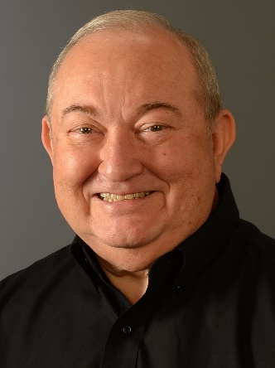
Cecil Martin, ACSC Treasurer

My name is Cecil Martin and I live in Columbia, SC with my wife Susan. We are members of several Shag Clubs, but our home club is Palmetto Shag Club. I have served as the ACSC Treasurer, SOS Charitable Foundation Treasurer and on the SOS Board since January 2017. I would like to ask for your consideration for the ACSC Treasurer position in the upcoming election. I have enjoyed being involved in the Association and serving as the ACSC Treasurer. I would appreciate your vote in the upcoming election at the ACSC meeting at Fall Migration in September.

In Palmetto Shag Club, I have served on the board as Treasurer, President and Past President. During that time, I set up a new online accounting system for the club and currently am the Accounting System Administrator, the Assistant Treasurer and Website Manager. Also, I set up a new online accounting system for the ACSC and the SOS Charitable Foundation.

I am a graduate of the University of South Carolina having received a Bachelor of Science Degree in Engineering in 1971 and a Master's of Business Administration in 1978 and am an avid fan of the Gamecocks.

For over 30 years, I worked as either a business owner or as a business manager. In these positions, I was responsible for the overall management of the business which included Accounting, Marketing, Sales, Finance and Operations. I have always been willing to assist others when asked. I have presented twice as part of the Programs at ACSC Workshops. I was recognized as a Shag Icon in 2017.

I hope to see you on the dance floor at Fall Migration in September..

Best Regards,
Cecil Martin

